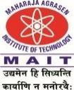**MAHARAJA AGRASEN INSTITUTE OF TECHNOLOGY**

**Department of Computer Science and Engineering**

**Department Vision**

To be centre of excellence in education, research and technology transfer in the field of computer engineering and promote entrepreneurship and ethical values.

**Department Mission**

To foster an open, multidisciplinary and highly collaborative research environment to produce world-class engineers capable of providing innovative solutions to real-life problems and fulfil societal needs.